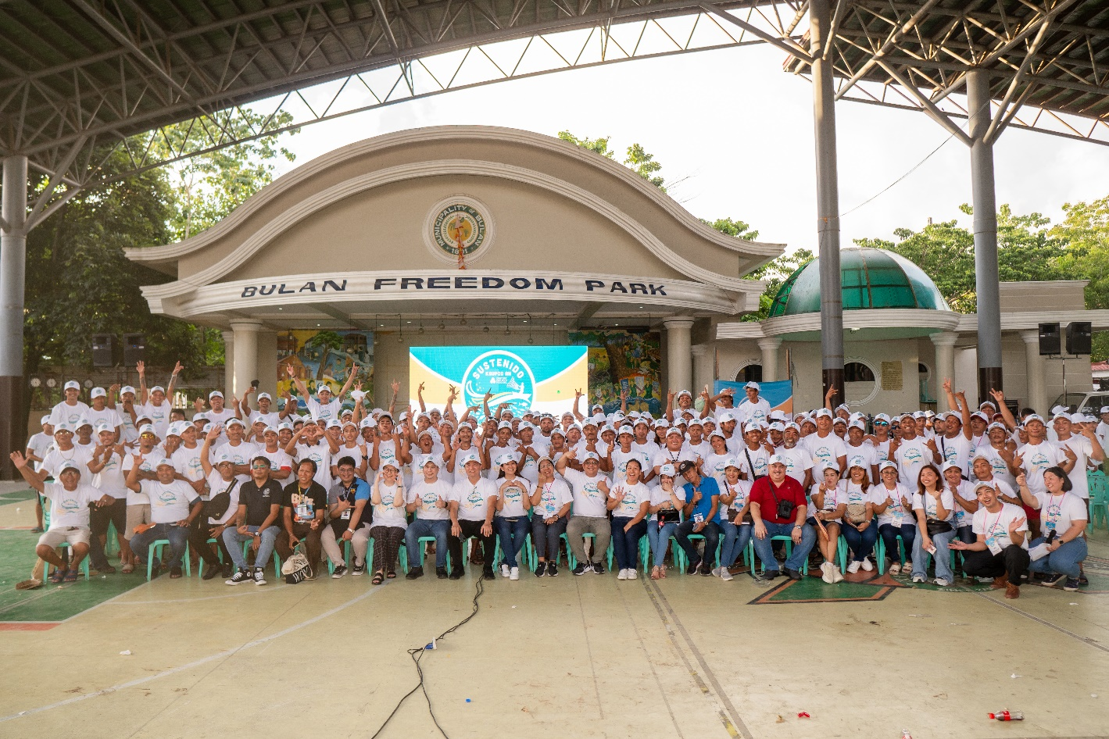

*Sustenido Bulan Sustainable Fishing Training Program for Smallholder Fisherfolk*

**Century Pacific Champions Sustainable Sardine Fishing**

**Recognized at 2025 Tambuli Awards for Corporate Purpose-Driven Impact**

***Century Pacific Food, Inc.*** *(PSE:CNPF), one of the leading food companies in the Philippines, reinforces its sustainability agenda with initiative* ***Sustenido Bulan*** *– a holistic program that promotes inclusive growth and sustainable sardine fishing practices among smallholder fisherfolk in Bulan, Sorsogon. At the recently held 2025 Tambuli Awards, the group was honored for Corporate Purpose-Driven Impact – gold for Inclusive Growth and silver for Care for the Environment.*

The recognition reflects the meaningful outcome of the program. *Sustenido Bulan* has resulted in a significant 10% reduction in fish rejection rates, which effectively minimized food and marine waste while boosting the incomes of over 200 smallholder fisherfolk. The initiative created more than 850 local jobs and enabled the production of over 65 million servings of quality sardine products.

Moreover, the company extended its flagship school feeding program *Kain Po*, through the RSPo Foundation, reaching over 1,000 children in Bulan with regular servings of protein-rich meals.

Beyond its social and environmental outcomes, the program has also delivered strong business results. Developing a more resilient supply chain has enabled CNPF’s sardine business—home to brands such as 555 and Ligo—to achieve profitable growth.

To bring this to life, CNPF partnered with the local government and the Bureau of Fisheries and Aquatic Resources to deliver training on sustainable fishing practices.

The broader context underscores the urgency of this initiative. Sardines are among the most vital food staples in the Philippines, found in 9 out of 10 households (Oceana Philippines, 2017). However, the industry has faced mounting pressures in recent years—declining catch volumes in key fishing hubs caused by climate change, unsustainable practices, and seasonal unpredictability. With major fishing grounds now under rehabilitation, *Sustenido Bulan* was launched to ease pressure on traditional sources and promote sustainable fishing practices—ensuring long-term sustainability for both community and company.

**. . .**

*(L-R Glo Sarmiento, Mayette Siasoco, Kamille Corpuz, Karen Avila, Gela Pecson, Greg Banzon, Karen Singian, Ron Agoncillo, Jenny Tan, Judy Culangan, Dappy Tecson, Ferinand Bondoy and Harvey Llamosa with Tambuli Jury)*

At the 2025 Tambuli Awards held on the 3rd of June 2025, CNPF garnered two awards, **Gold for Inclusive Growth and Silver for Care for the Environment for its Sustenido Bulan initiative**.

The awards were presented at the Grand Hyatt Suites in Taguig, where CPFI’s Sardines, Procurement, and RSPo team humbly accepted the recognition.

“These Tambuli represent more than recognition—they reflect the values we strive to uphold,” said Ronald M. Agoncillo, Vice President and General Manager of Sardines. “What began as a necessity became a partnership and a mission. Through our Sustenido Bulan initiative, we didn’t just improve fish quality or create jobs—we helped empower lives.”

The recognition reflects CNPF’s belief that corporate purpose and profitability are not mutually exclusive. “Too often, businesses see sustainability as an expense,” Greg H. Banzon, Executive Vice President and Chief Operating Officer noted. “Sustenido Bulan proves that real, lasting impact can drive shared prosperity. When communities and companies collaborate, inclusive growth and environmental care can go hand in hand.”

CNPF remains committed to scaling this model, and continuing its mission of nourishing lives, responsibly and sustainably.